Verifying that every radio button works properly

Verified that only one dish can be selected

Verified that only one scoops option can be selected

Verified that only one flavor can be selected

Verified that only one topping can be selected

Verified that the Exit button closes the application

Verifying that all the prices add up

\* There is a 20% tax on all purchases

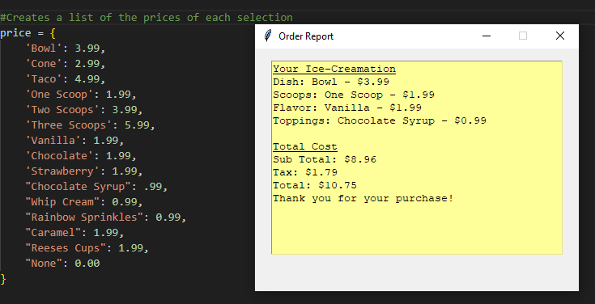

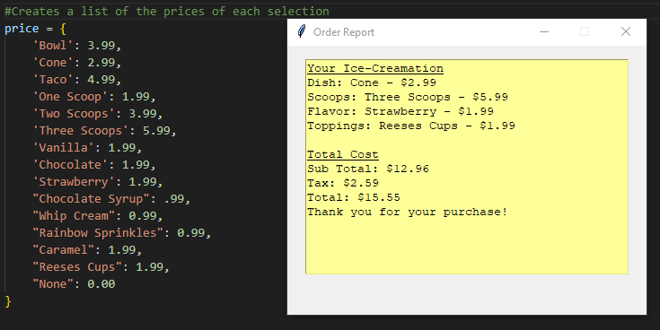

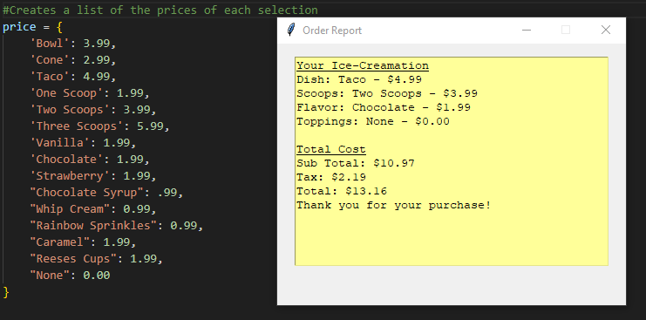

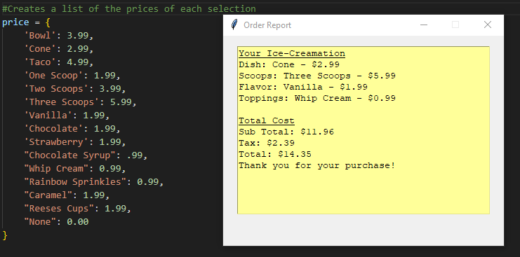

All of my code worked as I wanted it to. The prices added up correctly and you can switch up your order on the spot.